**MODULE 5**

1. **List out the platforms available for Social Media Marketing.**

**ANSWER :**

**Most popular platforms available for social media marketing are:**

* **Facebook**
* **Youtube**
* **Instagram**
* **Twitter**
* **LinkedIn**
* **Snapchat**

1. **How many types of content we can use for Social Media Marketing? Explain any three.**

**ANSWER:**

**One of the most important in any digital marketing work would be the website content. This is what the user will see when he lands on your page and if the content is not compelling for him to read they will jump back to the search results.**

**In Website should include, brief summary of the product your are selling and images with alt tag which explain the features of the product, a few customer testimonials and few relevant links to other pages (Internal, Outbound,Inbound)**

**--Entertainment:**

**The types of social media content to consider as entertaining include puzzles, fun holiday-related content, memes, viral videos, jokes, comics, contests or giveaways, and nostalgia-related content.**

**In social media platforms, we can read Jokes, Memes , Comics, Contests and Viral Videos.**

**one of which is the kind that entertains. People like to laugh or be amused, so it makes us feel good when we share that positive experience with others.**

**From a business point of view, entertaining content can help humanize a company into a group of people just like their audience.**

**So how do you create entertaining content?**

* **Use information that people simply have too share like juicy gossip like this video**

**--Education:**

**Informative blog path , Tips and Tricks, Case Studies, Live video Training are giving information about Education. We give any tips like a**

* **Use humor in your content.**
* **Incorporate interactivity into your content, for example, write something that calls for interaction and follow up with the feedback you collect.**
* **Inject something different into your routine, for example, use video if you tend to write a lot and**[**present webinars**](https://nealschaffer.com/promote-webinar-social-media/)**.**
* [**Tell remarkable stories**](https://nealschaffer.com/boost-sales-social-media-storytelling/)**that connect relatable people, places, or things in a way that personalizes it and engages your audience.**
* **Present enthralling biographies. Conduct an online event. Highlight a book or documentary. Create content to retain customers, not just acquire them.**

**--Inspiration:**

**Types of social media content that you could use include**[**quotes**](https://nealschaffer.com/top-25-social-media-for-business-quotes/)**, amazing facts/trivia, personal stories of triumph, and images.**

* **The first (about 33% of the time) is because the experience was so good, unique, or new that it had to be shared.**
* **The second (about 24%) is to gain attention by showing others your superiority. For example – you were part of an exclusive club of buyers or have inside information.**
* **The third (around 20%) is from a desire to help and express caring or friendship.**
* **The fourth (also around 20%) is because the content is so wonderful, funny, or brilliant that it just has to be shared.**

**--Promotional :**

**Types of social media content that you can use for promotion include: promotions, coupons, discounts, freebies for sign-ups, client testimonials, and webinars.**

1. **Why should we use Social Media Marketing to promote our business?**

**ANSWER:**

**Benefits of social media marketing to promote for business:**

* **attract customers, get customer feedback and build customer loyalty.**
* **increase your market reach, including international markets.**
* **do market research and reduce marketing costs.**
* **increase revenue by building customer networks and advertising.**
* **develop your brand.**

1. **What is the relationship between SEO and Social Media Marketing?**

**ANSWER:**

**Social media marketing relates to posting and optimizing your content on social media networks like Facebook, Twitter, or Instagram.**

**SEO strategy relates to making your website or content more searchable so that people looking up phrases or questions about products or topics related to your company will find your site in the results.**

1. **Prepare a word file in which you should add:**

**o Type of content to create on YouTube for**

[**http://www.designer2developer.com**](http://www.designer2developer.com)

**o Suitable topic list for http://www.designer2developer.com according**

**to your research on Google trends**

**o List out the points to include in the video**

**o Suitable title and description for the video**

**o Keywords to target and its placement**

1. **What are tools we can use for Marketing on a platform like Facebook**

**and Instagram?**

**ANSWER:**

**Facebook can be used to advertise and promote your products and services to a large audience.**

**It is the social-media platform of choice for the majority of marketers.**

**Facebook and Instragram are two of the most popular mobile platforms.**

**We can create advertising in Instagram and we can promote our product and services in just few minutes like Facebook.**

**In Facebook and Instagram , we can create campaign and we get best performance for website click, website conversion.**

1. **What type of traffic you will get on platform like Linked-In?**

**ANSWER:**

**Linked-In is a business oriented social networking site. Linked-In is one of the most used social media channels for professional use.**

1. **Create social media presence (page or account) which helps your website and blog.**

**ANSWER:**

**We create account on social media to facebook via blog and we send link below:**

[**https://www.facebook.com/profile.php?id=100085135502515**](https://www.facebook.com/profile.php?id=100085135502515)

1. **Prepare an excel sheet for posts of www.esellerhub.com to publish on Facebook, Instagram and Linked In.**

**ANSWER:**

1. **What is the use of E-mail marketing?**

**ANSWER:**

**E-mail marketing is one of the oldest and most popular digital marketing techniques.There are so many sites that provide readymade templates that need you just to go sign up for the service and you are on your way to sending beautiful emails.**

1. **What goals you can achieve with the help of email marketing?**

**ANSWER:**

**We can many goals achieve with the help of email marketing like a**

* **Grow email subscriber list**
* **Increase open rates**
* **Improve click- through rates**
* **Ratain current customers**
* **Reduce unsubscribes**

1. **Create Sign-up / Subscriber pop-up form for your blog and website using email marketing tools to collect audience data .**

**ANSWER:**

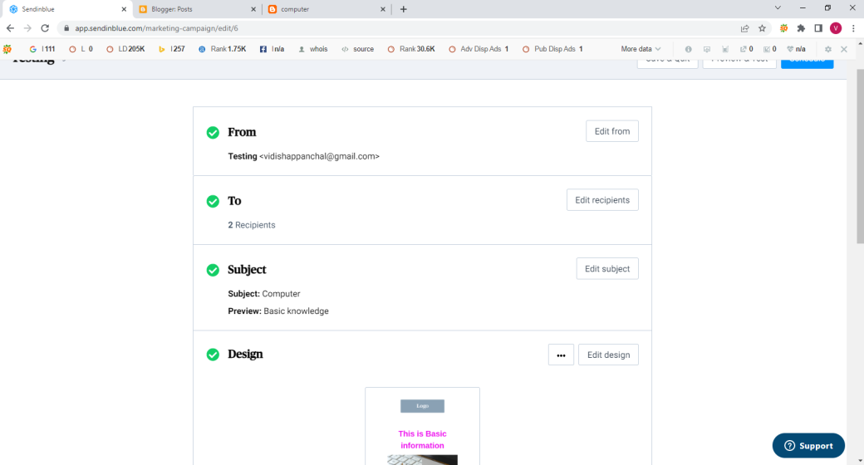

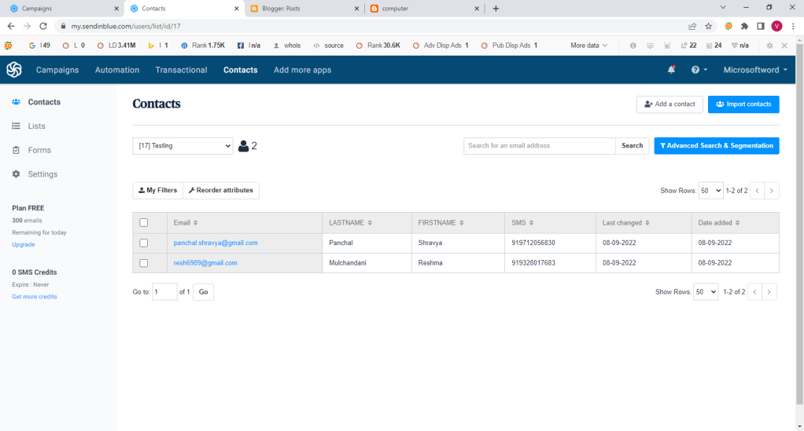

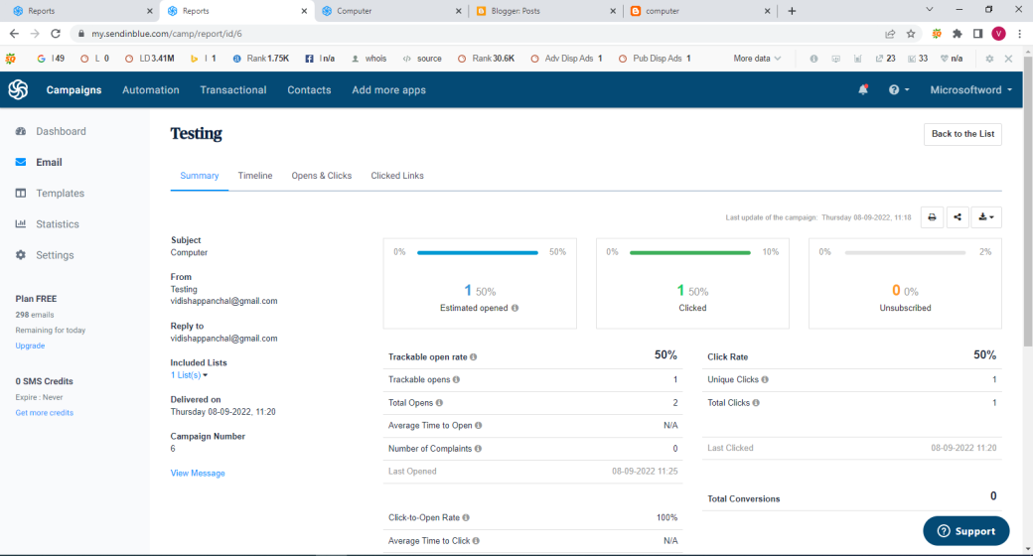

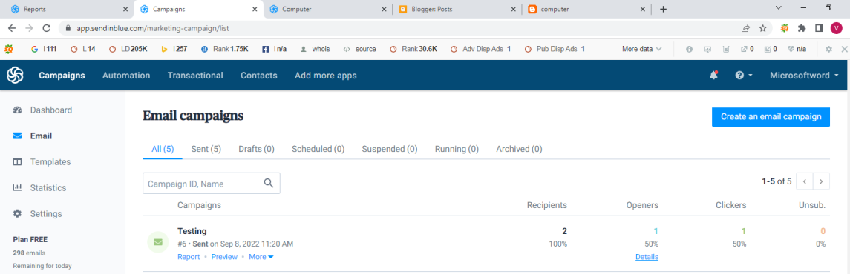

1. **What is affiliate Marketing?**

**ANSWER:**

**Affiliate marketing is when you sell somebody else's product online for a commission. For example, an established company may have a product or a catalog of products, either digital or physical. They let others promote and sell those products, paying them a commission every time they sell something.**

1. **List some famous websites available for affiliate marketing.**

**ANSWER:**

1. **Amazon affiliates**
2. **Shopify Affiliate Program**
3. **eBsay Partners**
4. **Clickbank**
5. **SEMRush**
6. **Which are the platforms you can use for affiliate marketing?**

**ANSWER:**

**-Amazon Associate:**

**Amazon Associates is a good platform for bloggers and influencers who want to promote products to their recipients.**

**-ClickBank:**

**Bloggers and influencers that wish to market products to their audiences should use Clickbank.**

**-ShareASale:**

**ShareASale provides tools that make it easy to track your sales and earnings. It is also open to any affiliate marketers, whether you're just starting or an experienced pro.**

**-Walmart Affiliates :**

**The Walmart Affiliates Program is one of the best affiliate marketing programs available. You can earn up to eight percent commission on qualifying sales, and there is no minimum purchase amount.**